Snapshot of launching static web page using apache2 web server:

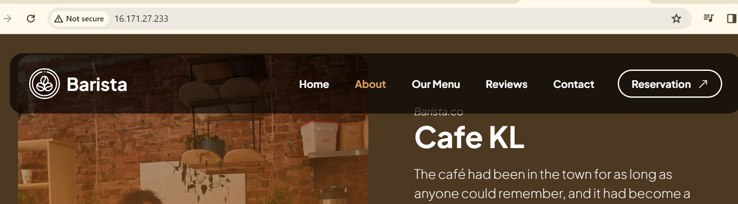

Snapshot of executing simple html page using apache2 web server:

